investigate Kriging variance as a proxy for als dem accuracy

Yu-Hang Cho¹ and Chi-Kuei Wang*²
¹MasterStudent, Geomatics, National Cheng Kung University
No.1, University Road, Tainan City 701, Taiwan.
Email: P66101095@gs.ncku.edu.tw

²Professor, Geomatics, National Cheng Kung University,
No.1, University Road, Tainan City 701, Taiwan.
Email: chikuei@ncku.edu.tw

KEY WORDS: airborne laser scanning, point cloud, Kriging, digital elevation model

ABSTRACT: Airborne laser scanning (ALS) is widely adopted to acquire digital elevation models (DEMs) of the Earth's surface due to its ability to penetrate tree canopies. DEMs are derived by interpolating ground points acquired from ALS data. In this research, we selected Kriging as the interpolation method, which is popular for its consideration of best linear unbiased estimator (BLUE) and spatial correlation in the data. Kriging assumes data in the space have a certain degree of correlation. The spatial correlation is associated with the spatial distribution and distance of the data and is used to calculate both Kriging estimation and Kriging variance. Kriging estimation represents the DEM, while Kriging variance serves to assess the accuracy of Kriging estimator. For example, in thick canopies areas with limited ground points, the accuracy of Kriging estimation may decrease. In these cases, Kriging variance quantifies the accuracy of Kriging estimator, where a larger value indicates weaker spatial correlation and lower estimation accuracy, and vice versa. The reason why we focused on Kriging variance is that though we can use root mean square error (RMSE) to assess the accuracy of DEM. However, we can only get one value for whole site. If we want to know the accuracy of each grid, kriging variance is the best proxy. Our research encompasses 60 regions, including mountainous and hilly terrains, specifically selected to test the accuracy of void areas. Initially, we created voids of different sizes on mountain peaks, valleys, and slopes to simulate dense canopies areas. Subsequently, we calculated spatial correlation of data through semi-variogram model, with an emphasis on selecting the appropriate theoretical model and adjusting the range, which controls the consideration of spatial correlation within a given distance while disregarding those further away. In our study, range was adjusted based on void sizes to achieve better fit for the semi-variogram model. And the lag distance we used is 0.5 meter because the nominal ground point density is 2 points per meter square. After determining the spatial correlation of the data, we calculated the Kriging estimation and Kriging variance to assess the accuracy of DEM affected by different sizes and locations of voids. Then through cross validation, we calculated RMSE to validate the selection of Kriging parameters and evaluate the performance of it.

introduction

Motivation
In Taiwan, we use a figure called “void diagram” to assess the quality of ground points from ALS point cloud. Void diagram is derived by calculating Delaunay triangulation. When the length of triangle is large, it represents that there is lack of ground points. Thus, we can use this void diagram to get an overview and exam the distribution of points. Figure 1. shows that we define the length into 7 parts. Areas with sparse points are presented as darker colors. However, this method cannot precisely provide the value to quantify the quality. It’s more about visualization. We want to produce something that can evaluate the accuracy of our DEM. Thus, we head to find a much more appropriate interpolation method that can give the quality assessment. Interpolation methods always give the prediction result and then use RMSE to do the accuracy assessment. However, RMSE can only give one value for whole study site. It cannot give furthermore information. But Kriging can do it. Besides providing prediction result, it also calculates Kriging variance, which assess the accuracy of each grid. Rely on this output, we can quantify the quality of ALS derived DEM in detail.
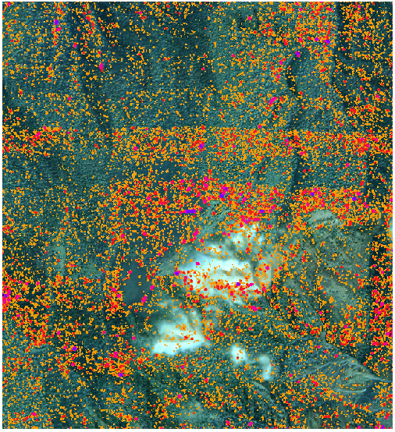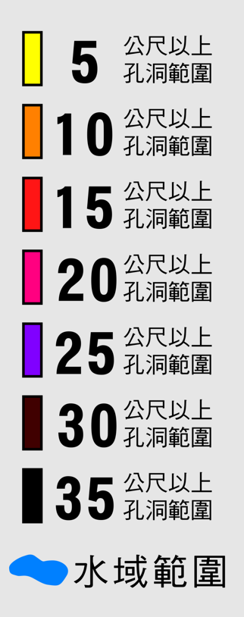
Figure 1. Void diagram of ground points (Kuo et.al 2016)

Aims
Nowadays, ALS is a common way to gather topographical information. It can acquire dense points that involve 3D coordinates, intensity, reflections, and so on. Through the steps of removing noise and classification, we can finally define which point is belong to ground point. Then, by using these ground points, DEMs can be conducted through various interpolation methods. The part of choosing interpolation methods is an important issue that is needed to discuss. And then we finally choose Kriging method depend on its ability to calculate Kriging variance.
To improve the method of DEM accuracy assessment, we take Kriging method instead of using void diagram. In this research, we design some different scenarios of terrain and test on Kriging parameters to investigate the influence of lack of points.

Overview
The main body of this paper is consisted of several parts, start with a brief introduction of Kriging algorithms, including three kinds of Kriging, simple, ordinary, and universal. And then the reason why we used ordinary Kriging. The following is the dataset. Then we modified some parts to simulate the scenarios of lack of points in different terrain. After the Kriging calculation, there is the result and discussion.

Reference to related work
Before, we can only use point density or number of points to examine the quality of ALS point cloud. Now, we adopt Delaunay triangulation to procedure void diagram to inspect the quality, However, these methods cannot quantify the point cloud data. Thus, we adopt Kriging methods to have a proxy for ALS DEM accuracy. These result can help to assess the reliability of ALS flight plan and progress.

algorithms
There are several kinds of Kriging that have different assumptions: simple Kriging with constant mean, ordinary Kriging with local mean, universal Kriging with the trend, and so on. The algorithms of different Kriging methods are similar with minor differences. There are two main outputs of it are Kriging prediction and Kriging variance. Kriging prediction gives the interpolation result and Kriging variance gives the confidence of Kriging prediction. In this task, we mainly adopt ordinary Kriging without trend.
To produce the kriging mean we need to focus on two important concepts in kriging algorithms first, covariance, and variogram, some studies call it semi-variogram. Covariance represents the correlation between two variables and the variogram represents the degree of different between two variables. These two are contrast concepts. The covariance formula is like below:
$C\left(h\right)=E[\left(Z\left(u\right)-\overline{Z})\left(Z\left(u+h\right)-\overline{Z}\right)\right]=\frac{1}{n-1}\sum_{i=1}^{n}{\left(z_{i}-\overline{Z}\right)\left(z_{j}-\overline{Z}\right)}$ (1)
$\left|x_{i}-x_{j}\right|=h$ (2)
$C\left(h\right)=Var\left(Z\right)$ (3)
$For \left|h\right|=0$ (4)
where C = covariance
E = exception
Z = union of sample data
$\overline{Z}$ = mean
u = value of specific location
h = distance

Then the variogram formula is like below:
$γ\left(h\right)=\frac{1}{2}E\left[{\left(Z\left(u\right)-Z\left(u+h\right)\right)}^{2}\right]=\frac{1}{2}\frac{1}{n-1}\sum_{i=1}^{n}{{\left(z_{i}-z_{j}\right)}^{2}=Var\left(Z\right)-C(h)}$ (5)
where $γ$ = variogram

We can notice that variogram is not related to the value of sample mean. It is important that the definition of sample mean in different type of kriging are different. Through the calculation, we can product a figure that represents the relationship between variogram and the distance. Figure 2. has some parameters. We can regard nugget as a noise sometimes, its name is from mining field. Because the distribution of gold is discrete and far from each other, it means that in a very short distance, there would be some degree of different. Sill is the variance, exactly. It represents the maximum difference between the variables. When the range is reaching the distance that the variogram does not increase, we can regard those data is not correlated with the specific point. Thus, we don’t need to consider them. These parameters are adjusted depend on our data and experiments in this research.
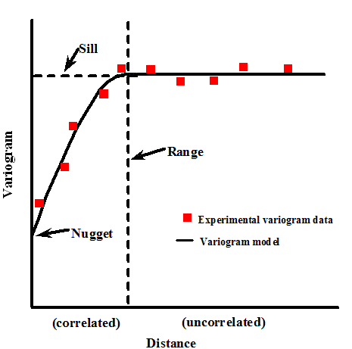
Figure 2. Variogram features (Emanuele Barca et al. 2016)

As Figure 2. shows, when the distance between points is getting longer, the variance also gets larger. After the calculation, which model better fit the experimental variogram needs to be considered. There are five kinds of common variogram models in Figure 3., spherical, circular, exponential, linear, and Gaussion model. The main difference of these model is that the degree of difference in the beginning. We can notice that in Gaussion model, the slope increases slowly in short distance, this characteristic better fit the data we use. We test hundreds of our terrain ground points data and it always shows the pattern of Gaussion model.
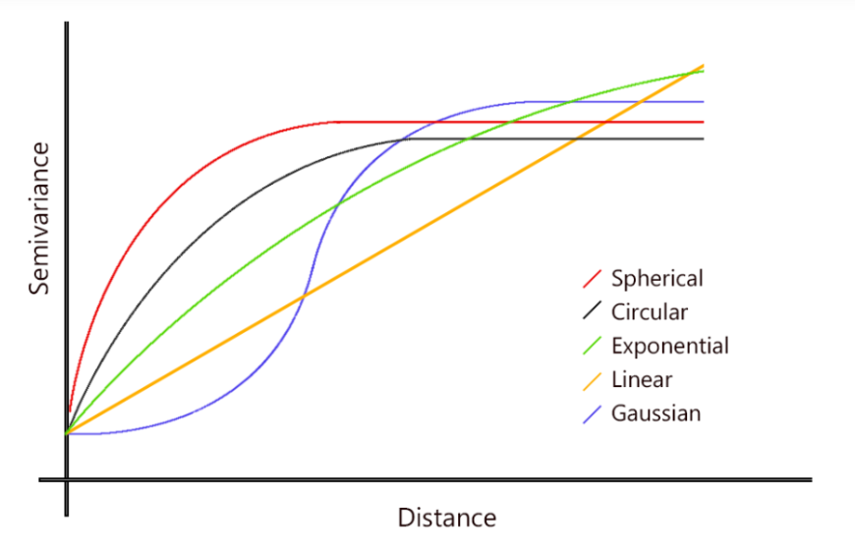
Figure 3. Different kinds of theoretical model (Open Source Geospatial Foundation)

Once the variogram model determined, we can head to calculate prediction result and Kriging variance.
When we finish the variogram model, we can keep calculating the several kinds of kriging. In kriging methods, best linear unbiased estimator (BLUE) is a core concept. Best means to minimize the variance. Linear means kriging formula is a linear composition. Unbiased can be explained by the relationship between measurements and the mean. That is, the expectation of the difference between them is zero.
Steps of calculating kriging is first calculate the variogram. Second, fit the variogram model. Third, the kriging system calculation. In this step, we use the covariance between variables to calculate the weights. Them, we can get the kriging mean and kriging variance through their different definitions.
In simple kriging, it satisfies the second order stationary, in other words, it satisfies that the mean is known and does not change with the position. And the covariance only related to the distance between variables. The below formula shows the kriging mean $z_{0}^{*}$ and kriging variance $σ_{sk}^{2}$, the 0 represent the specific position we want to get.
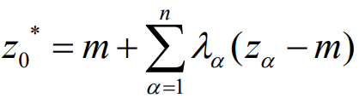 (6)
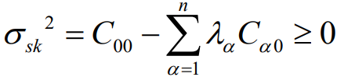 (7)
In ordinary kriging, the mean is not always the same. It’s a constant. However, it’s a trade off. OK needs to satisfy a constraint: the accumulated of weights equals to one. This, Lagrange multipliers is adopted. OK can also conduct kriging mean and kriging variance individually.
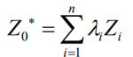 (8)
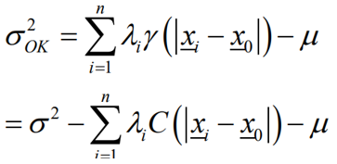 (9)
Universal kriging no longer satisfies the station assumption. Thus, the mean value of it is differ in a deterministic way in different positions. Only the variance is a constant. It also considers the trend of the dataset.
In my data, each dataset is 200 meter squared. We only to consider the spatial relationship within 70 meters to reduce the computing time. Thus, we conduct a variogram model as Figure 4. shows. It only computes the spatial correlation within 70 meters. After acquiring the variogram model, we can use it for kriging computations. In this task, I use ordinary kriging with trend, ordinary kriging without trend(detrend), and universal kriging. My data is related to terrain, thus it has some kind of trend that influence the data. We can consider it as a first order, second order, or third order trend. In this case, we calculate the second order trend and them minus it before Kriging calculation, as Figure 5. as an example.
- Ordinary kriging: the computation is simple, use weighted to calculate the result
- Detrended ordinary kriging: before the ordinary kriging algorithm, minus the trend surface in elevation
- Universal kriging: consider the trend into the algorithm
The reason why we adopted detrended ordinary Kriging is that we need to consider the trend because of the data we used is about terrain. And then we can better define the type of trend if we simulate it by ourselves. When finishing the kriging methods, we would have kriging prediction and kriging variance. Then, adopting cross validation to exam the fitness of each variogram models.

data and study areas
We use ALS point cloud data with Taiwan 1/5000 map sheet as a unit and cut it into 200 meter squared as per study area. After the steps of removing noises and classification, we get the point cloud which only include ground points. The density is at least 2 ground points per square meter. We have these point cloud data of whole Taiwan and choose two kinds of terrain, mountainous and hilly areas because of the difference of high, distribution, roughness, and tree species. For the reason of simulating the scenarios of thick canopies, which results in sparse or no ground points acquired, we dig out different radius of circle of point cloud on peak, slope, and valley areas. The radius is from 5 meter to 25 meter. The reason why we choose these three kinds is that we want to see if the pattern of the terrain is different, it would affect the result of Kriging method or not. Thus, we finally use these three kinds from two main terrain, mountainous and hilly, and hollow different sizes of void to simulate thick canopies.

methodology
As the modification we did on our dataset, we hollowed the ground point cloud with different sizes of circle to simulate thick canopies that results in lack of points. We selected three kinds of topography variations: slope, valley, and peak in two kinds of terrain: mountainous and hilly. The reason why is that we think different terrain variations have its own pattern, and the pattern would affect the result of interpolation. After the preparation of data, we need to consider the trend of our dataset. The point cloud we used is about terrain. As we know, Kriging method consider the spatial correlation between points in the space. Thus, we need to simulate the trend surface and minus it to avoid the affection. Generally, we consider second order trend surface due to the consideration between computation time and precision. Once we get the second order surface, we minus it before doing Kriging calculation.
In Kriging calculation, there are so many parameters we can adjust. We can simply split the progress into three parts: variogram, prediction, and Kriging variance generation. In variogram generation, we set the parameters like Figure 2. shows, nuggets, sill, and range. Worth mentioning, the range we set is 70 meters. Consider the observation points of our data is sufficient even excessive, we need to decrease the computation time and also consider the spatial correlation. Then, choose Gaussion model as theoretical model to make the variogram model. Once the variogram model is determined, we can use it to compute Kriging prediction and Kriging variance. In this step we made 200-meter length of grid to do the interpolation to get 1-meter resolution result. The main part of this step is to set suitable points to calculate. There are two ways to constraint the points taken to consider. One is using distance and another uses number of points. We finally take second one and use neighbour 200 points to do the Kriging calculation. Then, after getting prediction result and Kriging variance, we adopted cross validation to see the appropriateness of the model.

results and discussion
We simulated around 60 different scenarios of point cloud to produce Kriging prediction and Kriging variance. Firstly, fit the second order trend of each data like Figure 4. shows. It contains 6 different scenarios. Upper ones are mountainous and lower ones are hilly terrain. From left to right is peak, slope, and valley in order. Here we only show 5-meter radius of hollowed circle for visualization. After we get the trend surface, minus it in Z value and head to calculate the variogram model. After calculating, fit the experimental model and theoretical model together to get the variogram model we want to use. The variogram models are shown in Figure 5. They all show the same pattern of Gaussion model and have good fitting in short ranges. These variogram models ensure the correlation between points in each dataset. Then, we can do the Kriging calculation. The output would be Kriging prediction (DEM) as Figure 6. shows and Kriging variance as Figure 7. shows. Left figure shows radius of 5-meter void. It doesn’t show much different with other locations because the void area is small, similar as other where are lack of points. The range is around 0.16 to 0.56. However, the right figure has range from 0.14 to 2.73. It shows a big circle where we crop the points. Thus, it proves that we can use it to as a proxy for ALS DEM accuracy. We output them into .tif format that we can put them into GIS software to do the analysis. We also output then into csv that record the prediction result and Kriging variance of each grid. Through our experiment, the value of Kriging variance is from 0 to 4 in 5-meter radius void data and from 0 to 20 in 25-meter radius void data. The terrain variation, peak, slope, and valley do not affect the result of Kriging method instead. However, there is a situation needed to be discussed. There are some values of Kriging variance very close to zero, about 1e-14. When we examine the data in detail, those pixels all have an observation point in the middle of each grid. This situation causes Kriging variance present close to zero. In other words, the prediction is accurate.

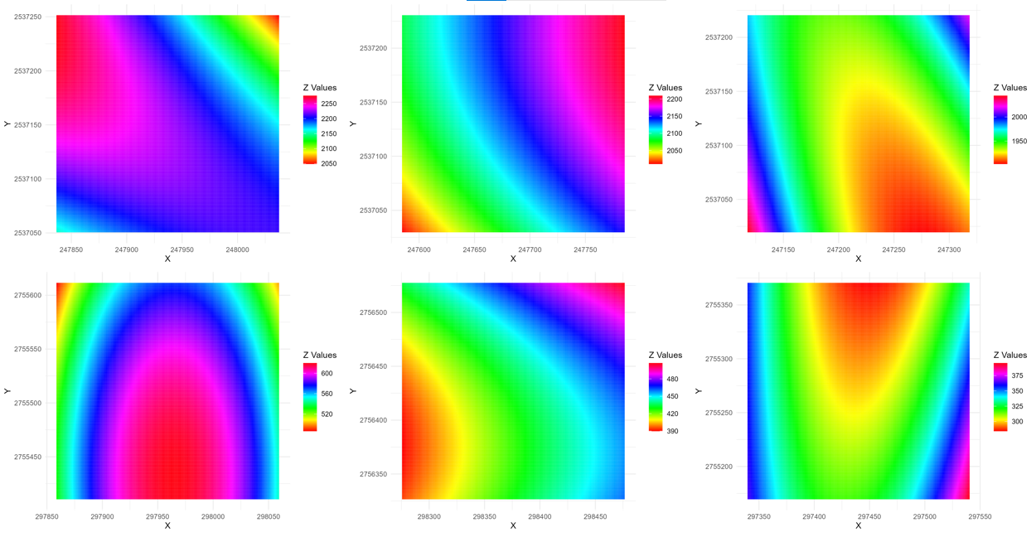
Figure 4. Second order trend surface of different study sites
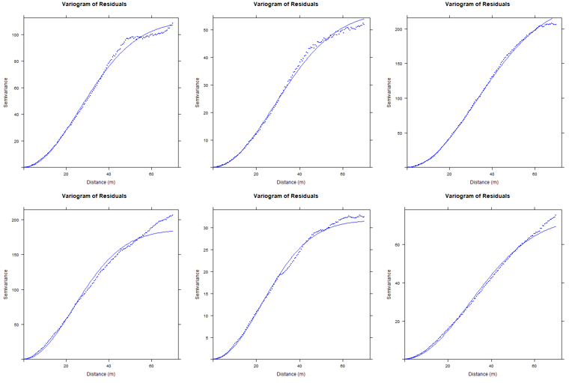
Figure 5. Variogram model of different study sites
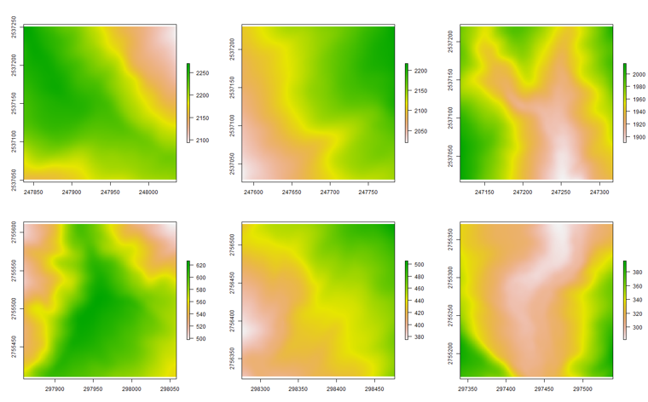
Figure 6. Kriging prediction result of different study sites(up 95181029M, down 96221039H,left2right PSV, void=10)

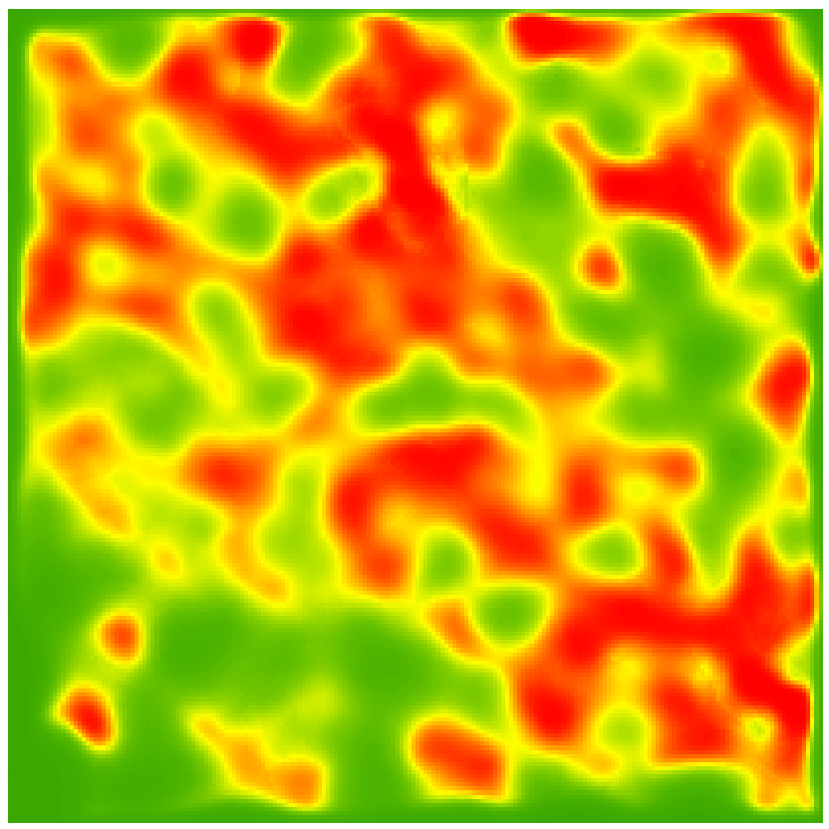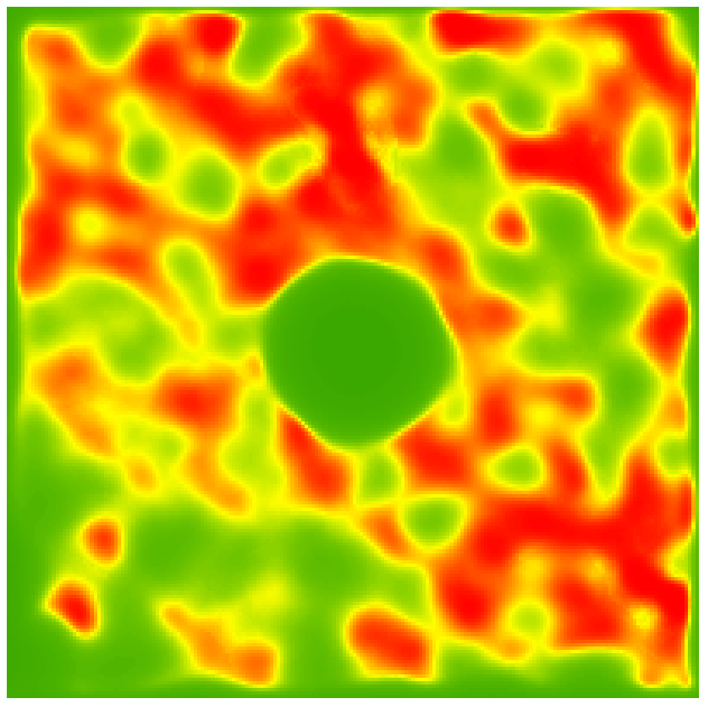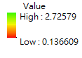
Figure 7. Kriging variance comparison of 5-meter and 25-meter radius void

Conclution
We designed different scenarios and parameters of Kriging to test whether Kriging variance can become a proxy of ALS DEM accuracy or not. The result shows that it can give a value of accuracy of each grid. This can help to assess the accuracy of ALS DEMs. Though the flight plan and overlap influence the data a lot. Data we used is from different companies with different LiDAR. Thus, the range of Kriging variance would have some degree of difference that affect the results. The steps of filter the raw data and classification also affect our experiment. However, we examine the Kriging variance and design different scenarios to prove that Kriging variance is a suitable proxy to assess the accuracy of estimator instead of using void diagram.

references
References from Journals:
Deutsch, C.V. and A.G. Journel. 1998. GSLIB Geostatistical Software Library and User's Guide, 2nd Edition, Applied Geostatistics Series, Oxford University Press, Inc. New York, NY.
Emanuele Barca et al., 2016. Heuristic Rules for a Reliable Variogram Parameters Tuning. 6th EnvImeko - IMEKO TC19 Symposium on Environmental Instrumentation and Measurements.
Gilbert, RO. 1987. Statistical Methods for Environmental Pollution Monitoring. Van Nostrand Reinhold, New York.
Mihnea Căt,eanu and Arcadie Ciubotaru, ISPRS Int. J. Geo-Inf. 2020, 9, 224; doi:10.3390/ijgi9040224, Accuracy of Ground Surface Interpolation from Airborne Laser Scanning (ALS) Data in Dense Forest Cover
Mihnea Căt,eanu and Arcadie Ciubotaru, Forests 2021, 12, 265. https://doi.org/10.3390/f12030265, The Effect of LiDAR Sampling Density on DTM Accuracy for Areas with Heavy Forest Cover
Sebastian Müller, Lennart Schüler, Alraune Zech, and Falk Heße, GSTools v1.3: a toolbox for geostatistical modelling in Python, Geoscientific Model Development, Received: 01 Sep 2021 – Discussion started: 19 Oct 2021 – Revised: 27 Jan 2022 – Accepted: 03 Feb 2022 – Published: 12 Apr 2022
Webster, R, and MA Oliver. 1993. How Large a Sample Is Needed to Estimate the Regional Variogram Adequately? . Geostatistics Troia '92 , ed. A Soares, Vol 1, pp. 155-66. Kluwer Academic Publishers, Dordrecht.
Wiesław Rokicki, Ewelina Gawell, Voronoi diagrams – architectural and structural rod structure research model optimization

